Chapter 11 Homework Problems

Problem 11.1

You are designing a bench grinder with an operating speed of 3600 rpm.

1. If you want the grinder to reach its full operating speed in 4 seconds, what must the rate of angular acceleration be in radians per second squared?
2. If the grinding wheel has a diameter of 8 inches, what will the speed of the surface of the wheel be?

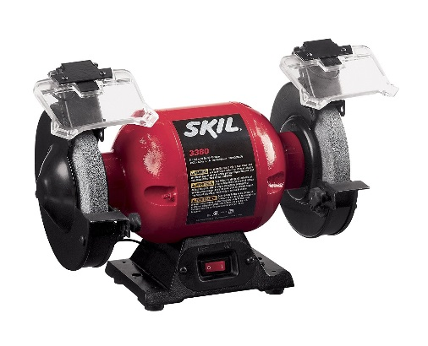

(Solution: $α=94.25\frac{rad}{s^{2}}$, v = 125.67 ft/s)

Problem 11.2

A belt driven system has an input at pulley A, which drives pulley B, which is attached with a solid shaft to pulley C, which drives pulley D. If the input is rotating at 60 rad/s counterclockwise, determine the angular velocity and direction of rotation for the output at D.

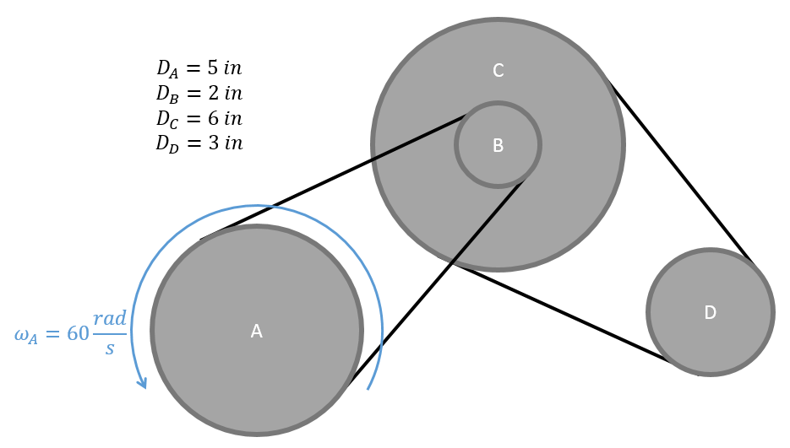

(Solution: $ω_{D}=300\frac{rad}{s}$ counter-clockwise)

Problem 11.3

The piston in a piston and crank mechanism has the velocity and acceleration shown below. Using absolute motion analysis, determine the current angular velocity and angular acceleration for the crank using absolute motion analysis.

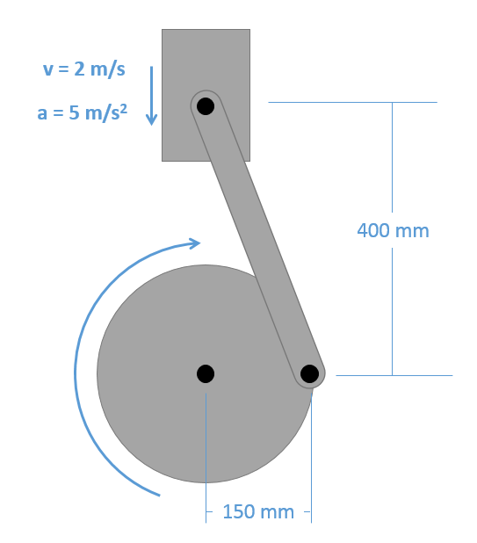

(Solution: $ω=13.33\frac{rad}{s}$ clockwise, $α=100.16\frac{rad}{s^{2}} clockwise$)

Problem 11.4

A trap door is being opened with a hydraulic cylinder extending at constant rate of .7 m/s. If the door is currently at a twenty degree angle as shown below, what is the current angular velocity and angular acceleration for the door?

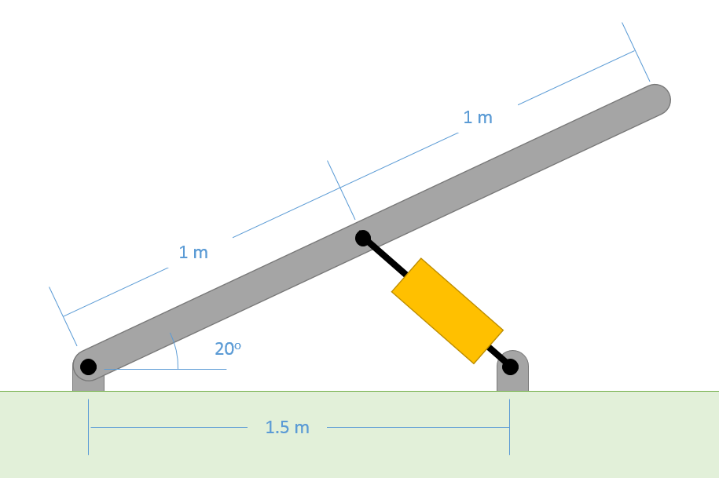

(Solution: $\dot{θ}=.896\frac{rad}{s}$, $\ddot{θ}=-1.246 rad/s^{2}$)

Problem 11.5

A robotic arm experiences the angular velocities and accelerations shown below. Based on this information, determine the velocity and the acceleration of the end of the arm in the x and y directions.

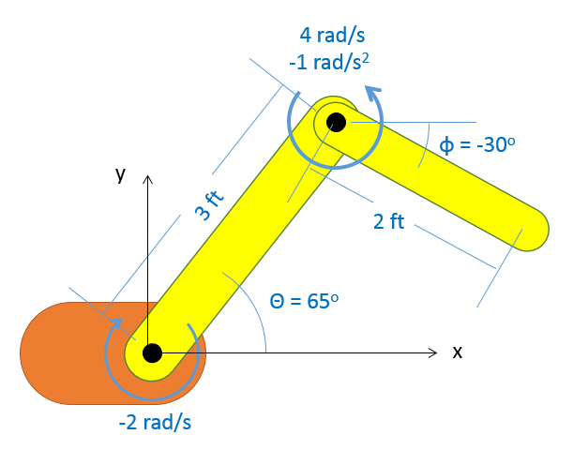

(Solution: vx = 9.44 ft/s, vy = 4.39 ft/s, ax = -33.78 ft/s2, ay = 3.39 ft/s2)

Problem 11.6

The piston in a piston and crank mechanism has the velocity and acceleration shown below. Based on this information, determine the current angular velocity and angular acceleration for the crank using relative motion analysis.



(Solution: $ω=13.33\frac{rad}{s}$ clockwise, $α=100.16\frac{rad}{s^{2}} clockwise$)